**DAX Queries for IPL ANALYSIS DASHBOARD:**

**TITLE WINNER**:

Title Winner = VAR max_date = CALCULATE(MAX('Calendar Table'[Date]),ALLSELECTED(ipl_matches_2008_2022),VALUES(ipl_matches_2008_2022))

var title_winner = CALCULATE(SELECTEDVALUE(ipl_matches_2008_2022[winning_team]),'Calendar Table'[Date] = max_date)

return title_winner

**Season dropdown:**

**ORANGE CAP Winner (score) + 'Runs':**

Batter Runs = CONCATENATE(SUM(ipl_ball_by_ball_2008_2022[batsman_run])," Runs")

**PURPLE CAP Winner (score) + 'Wickets':**

Bowler Wickets = CONCATENATE(SUM(ipl_ball_by_ball_2008_2022[iswicket_delivery]), " Wickets")

**Strike rate of a batsman:**

Strike rate for Batsman = (SUM(ipl_ball_by_ball_2008_2022[batsman_run])/COUNT(ipl_ball_by_ball_2008_2022[ball_number]))*100

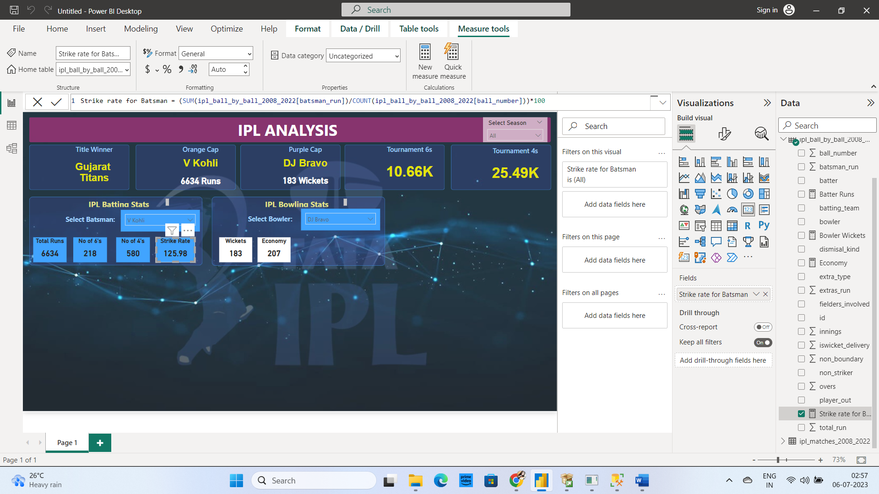

**Economy of a Bowler:**

Economy = DIVIDE(

            SUMX(

            FILTER(ipl_ball_by_ball_2008_2022, ipl_ball_by_ball_2008_2022[extra_type]<>"legbyes" && ipl_ball_by_ball_2008_2022[extra_type]<>"byes"),ipl_ball_by_ball_2008_2022[total_run]), (COUNT(ipl_ball_by_ball_2008_2022[overs]))/6

)

**Bowling Avg:**

Average by Bowler = DIVIDE(

            SUMX(

            FILTER(ipl_ball_by_ball_2008_2022, ipl_ball_by_ball_2008_2022[extra_type]<>"legbyes" && ipl_ball_by_ball_2008_2022[extra_type]<>"byes"),ipl_ball_by_ball_2008_2022[total_run]), SUM(ipl_ball_by_ball_2008_2022[iswicket_delivery])

)

**Bowling SR:**

Bowling SR = COUNT(ipl_ball_by_ball_2008_2022[bowler])/SUM(ipl_ball_by_ball_2008_2022[iswicket_delivery])

